Author: Ray Bartlett -- www.kaisora.com
Last Modified: 2007 Jan 26

How to use Kmail, Kiten, Konqueror, and Emacs to make JBDrill EUC_JP-encoded cardfiles.

(First the disclaimer: I'm sorry this isn't going to conform to any document formats. And I write it with the usual non-guarantee -- this will hopefully make it easier for some folks out there to use JBDrill and make their own cardfiles, but I'm not a tech person and don't even know programming. Use these directions at your own risk -- if they make your computer explode, your dog die, your girlfriend leave you, or anything else, it's your own fault. Don't say you weren't warned!)

1. Getting the files. All of the above (except JBDrill!) should be standard on most Fedora distributions and will probably be easily found with "yum" but I don't know. JBDrill is on Jim Breen's site here.

Despite the dire warning above, I'm pretty sure this will be a good experience for most beginning-to-intermediate Japanese learners. Jim Breen's JBDrill1.0 is a simple but very powerful little flashcard-style quiz program which, for all I know, I may be the only regular user. I take no credit for anything in the creation of it; however I have used it enough to know some tips and tricks, and it has made flashcard-style learning infinitely easier for me so I thought I'd share.

Here's a screenshot of JBDrill1.0 (Fig 1):

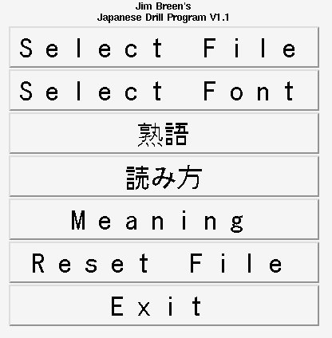

This is what you see when you start the program. The first thing you have to do is select a file (more on that later), which you can create yourself or download here (they are currently included with JBDrill). If you forget and click on the Jukugo or Yomikata buttons (or Meaning or Reset), you'll get an error message...but it doesn't crash the program. It just means you haven't yet selected a file.

(I've donated a few files just to get you started, but it would be great if others could contribute cardfiles too. Levels 1, 2, 3, 4, 5, 6 kanji-learning words, for example...or additional medical words, natural history words, and so on, much the way people have made different edict-based dictionaries. If you've made a cardfile, please consider sharing it with the world.)

If you don't like the font (it may be blocky -- the above is using the "Sazanami Gothic" font (it should "yum" install if it's not already included). It's possible that future versions of JBDrill will offer a "Set as Default" option, but if you get sick of changing it each time you run the program, open JBDrill.tcl with your favorite text editor and change the line that reads: font create selfont -family "helvetica" -size 24 and change what's in quotes to a corresponding font that's installed that you like, such as "sazanami gothic" (and if you like the size as well). Here's an example from my jbdrill.tcl file:

font create selfont -family "sazanami gothic" -size 30

It's never a bad idea to add a comment that you've changed it from the original, too, just in case something goes wrong.

Now, you're ready to select a cardfile. If you've already downloaded one, JBDrill automatically shows only the files with a .vcb extension. Just select the one you'd like to study and click "okay."

You'll return to the same screen shown above (Fig 1). But when you click the Jukugo button this time, a new window pops up, that looks like this (Fig 2):

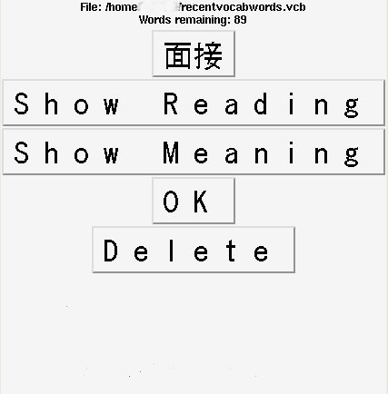

The Kanji is shown at the top. When you click "Show Reading" the hiragana/katakana reading appears. If you click on "Show Meaning" the English (or your language of choice) is displayed, as shown here (Fig 3):

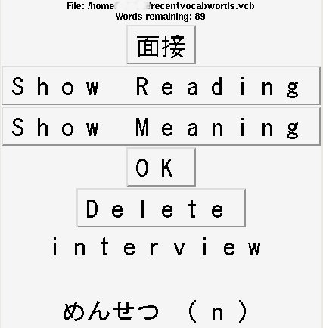

It's simple, but it does the job.

When you click Delete, the word is "hidden" from the remainder of the quiz. That's very useful once you know a word well and don't want to keep having it show up. It does not delete it from your actual cardfile, and if you decide to start over again with all the words, just press "Reset File" on the main window. To go to the next card in the list, you just click on the Jukugo button (or Yomikata or Meaning, whichever you wish to be quizzed on). If there are no words left, the program will exit.

Now, you've gotten tired of the simple cardfiles here and want to make your own. All you need is a semicolon delimited list in EUC_JP format. The format is the Japanese character first, the hiragana/katakana second, and then the meanings, each separated by a semicolon. For example:

漢字; かんじ; japanese characters;

If this were the only line in a cardfile, it would have only one card. Multiple cards are added by adding new lines, as shown here:

漢字; かんじ; japanese characters;
作家; さっか; fiction writer;
温泉; おんせん; onsen; hot spa;
ビール; ビール; beer; delicious malt beverage;
酒; さけ; rice wine;

And so on. As far as I know the cardfile does not have a size limit. You can simply add words to the list indefinitely. And since it's just a simple text file, it's easy to divide up a bigger file into smaller pieces, such as (in the above example), if one wanted to separate out the two alcohol words for specific study, or send a collection of words to a friend. Note that a Katakana entry (or any non-kanji entry) needs to be repeated or else an English meaning will end up in the "Yomikata" slot. If you want to make phrase cardfiles, they could be easily done in the same way -- kanji phrase, yomikata phrase, and English meaning.

Now, JBDrill basics learned, Kiten enters the scene. Kiten is a KDE, Edict-based dictionary which has the extremely useful feature of automatically searching words in the clipboard. (Note: this feature seems to only work with some applications -- Skype yes, OpenOffice no, Konqueror yes, Firefox no...I'm sure it relates to how the Klipboard is used and which apps are KDE ready, but I've no actual info or solutions. The worst case scenario is when a highlight doesn't automatically work I have to, horrors, click the middle mouse button. I can live with that.).

It works most of the time. So, for example, if I am in my email program (Kmail) and I come across a word I don't know, all I have to do is highlight the word and the meaning will appear in Kiten. I don't even have to Paste. By keeping the two apps open side by side, I can rapidly read pretty complex emails without needing to (laboriously!) highlight, paste, click, highlight, paste, click. Automatic clipboard searching is the way dictionaries should be.

However, it's still nice to sit back and actually study those words for a while. While Kiten has a learning tool for remembering individual kanji, it does not have anything yet that allows a user to save and playback entire words. Here's where JBDrill reenters, stage right. JBDrill is a boon to anyone who wants to make and remember their own sets of vocabulary words.

With Kiten in the "automatically search clipboard items" mode, all you have to do to make a JBDrill file is cut and paste the Kiten entry into an EUC_JP-encoded Emacs window, make sure it's semicolon delimited, and hit enter. Here's a screenshot of what I mean. This time I'm reading something in Japanese in Konqueror:

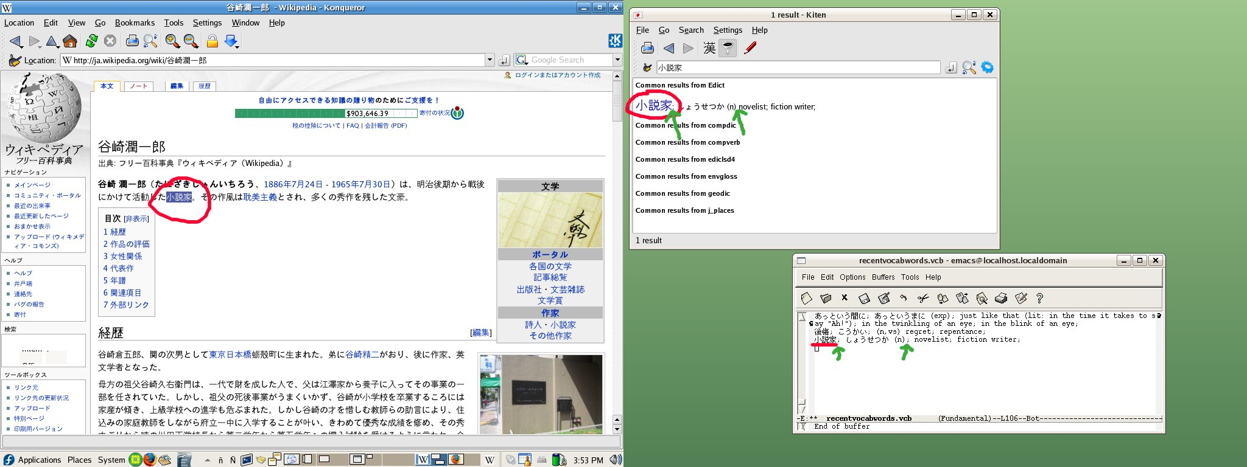
I've circled the word, which appears in Kiten as soon as I highlight it. Then, in the Emacs window (lower right), you can see where I've added it to an open .vcb file that I'm making.

Note the green arrows -- that's because the Edict/Kiten format currently uses a colon and a space, so I have to change these to semicolons manually each time I add a word. If you're doing just a few words it's easy to change them manually, but I finally got fed up and wrote a short shell script to do most of this for me. It changes the colon to a semicolon, and then inserts a semicolon into the space right after the part of speech, which works most of the time. A few Kiten/Edict entries don't have a part of speech string, so you may still have to add a semicolon or two by hand once in a while. It would be snazzier if it could detect those instances and insert a semicolon there too, but that's well beyond my limits. I was happy just to write this script as it is.

I call it "semicolon_inserter." (About the least imaginative name out there, but it gets the job done.) Make sure you chmod +x or it won't work.

#Semicolon_inserter 2007 Jan 26
#by Ray Bartlett -- www.kaisora.com
#
#Script to be shared by all, freely, as in love, beer, or those pieces of microwaveable food old ladies
#sometimes give away at supermarkets. Or free as in cheese. Mmm.
#
#Not sure if these 2 'export' lines are needed or not.
#Uncomment if you're finding the encoding is garbled
#when you run this. It might help, but I don't know.

#export LC_ALL=ja_JP.eucjp
#export LANG=ja_JP.eucjp

for file
do
echo $file
mv $file $$.tempfile
sed 's/[a-z])/&;/g
s/[a-z]5?)/&;/g
s/:/;/g
s/;;/;/g' $$.tempfile > $file
done
rm $$.tempfile

It should be noted that while Kiten is the Edict-based program I'm mainly using these days, I did almost the same thing with xjdic, and I suspect any Edict-based program will make JBDrill cardfiles pretty easily. You just have to manually cut and paste. With Kiten's clipboard autosearch, you're saved a highlight/paste step, so it's faster -- but any dictionary will work. And you can even create custom cards by hand.

An Emacs tip:
The easiest way to get Emacs to save in EUC_JP format is to open an existing EUC_JP-encoded file and delete the contents, then cut and paste your new file into it. For anyone finding that Emacs is not saving/opening their files in EUC_JP format, here's what you need to do (from RobertPupkin/FedoraForums):

- Open up emacs with an empty buffer, i.e. do not specify the filename on the command-line.
- In the Emacs menubar, go to Options -> Mule -> Set Language Environment -> Japanese
- In the Emacs menubar, go to Options -> Mule -> Select Input Method..., then hit Enter (japanese should be the default)
- Now open your file. The Japanese characters should display properly.
- If you would like this to happen everytime (so that you just can type "emacs somefile.vcb" at the command line) then choose Options > Save Options.

I hope this helps people get started using Jim Breen's great little flashcard program, JBDrill. I'm not really much of a tech person, but if you really desperately need to ask me a question, mosey over to my website and there's a link from there. I probably can't answer your question, so post it to the forums first where people who actually know something will have first crack at it. And if you make a set of cool vocabulary files, please consider sharing them. Or if you want to port this into Korean or something, that'd be really cool too.

